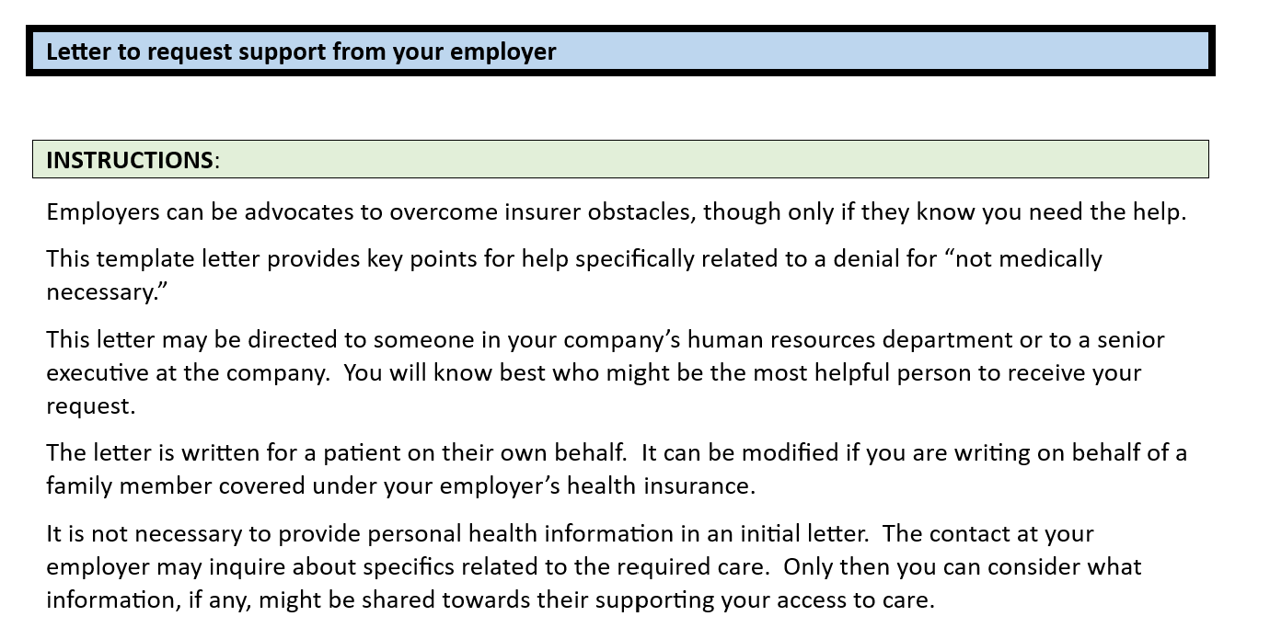

**TEMPLATE**:

**PERSONAL AND CONFIDENTIAL**

Date

Dear _____:

I am writing to ask your help me overcome an obstacle I’ve encountered with [HEALTH INSURER] related to access for medically-necessary care that should be covered by this employee benefit.

I prefer not to disclose the specifics of the required care, though below I’ll share sufficient information to document their obstacle to my care and the need for your assistance.

Medical necessity – I have provided [HEALTH INSURER] with a letter dated [DATE] from [NAME OF CLINICIAN] documenting his/her expert clinical judgment that the care now denied is medically necessary.

Denied care – [HEALTH INSURER] provided me with an Explanation of Benefits [or other document] dated [DATE] stating that the claim is denied and the care is not medically necessary. [If true, add this or similarly relevant information.] No clinician from the insurer has met with me, reviewed my medical records, and shown any qualification to evaluate medical necessity.

No success yet on my own – I have tried the following steps to resolve this issue, so far without success [include any of the following or others that apply]:

* Submitted the letter of medical necessity dated [DATE]
* Spoke with a customer service rep [PROVIDE NAME IF AVAIALBLE] who was not able to resolve their improper denial.
* Filed a formal complaint with the insurer
* Filed a formal complaint with [state insurance regulator]
* [insert other actions you have taken]

Sadly, it is not surprising that [HEALTH INSURER] is blocking my access to care. As you may know, there are frequent news reports of health insurers improperly denying claims, failing to provide adequate in-network resources, and treating some kinds of health care differently from others.

[If your employer has talked about the importance of mental health, consider including information about that commitment along with your request for support for help when you need it.]

This is to request your urgent help intervening with [HEALTH INSURER} to reverse this improper denial and to cover my medically necessary care as specified by my clinician.

Thank you.