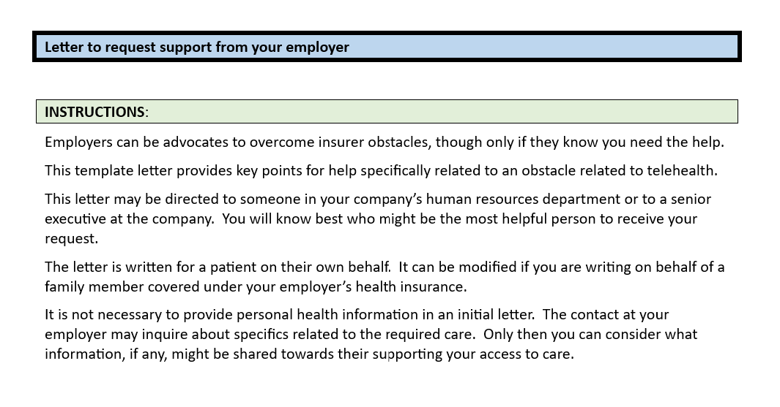

**TEMPLATE**:

**PERSONAL AND CONFIDENTIAL**

Date

Dear _____:

I am writing to ask your help me overcome an obstacle I’ve encountered with [HEALTH INSURER] related to telehealth access for medically-necessary care.

I prefer not to disclose the specifics of the required care, though below I’ll share sufficient information to document their obstacle to my care and the need for your assistance.

Access by telehealth – [explain the obstacle you have encountered related to telehealth], for example:

* “I have been denied access to telehealth care which should be covered by my insurance policy.”
* “There is no in-person, in-network provider available and the insurer has denied my access with telehealth.”
* “I prefer in-person care and my insurer is requiring that I use telehealth.”
* [some other reason”]

No success yet on my own – I have tried the following steps to resolve this issue, so far without success [include any of the following or others that apply]:

* Spoke with a customer service rep [PROVIDE NAME IF AVAILABLE] who was not able to resolve their improper denial.
* Filed a formal complaint with the insurer
* My provider has contacted the insurer regarding this situation.
* [insert other actions you have taken]

This is to request your urgent help intervening with [HEALTH INSURER} to expedite my having access to medically-necessary care.

Thank you.