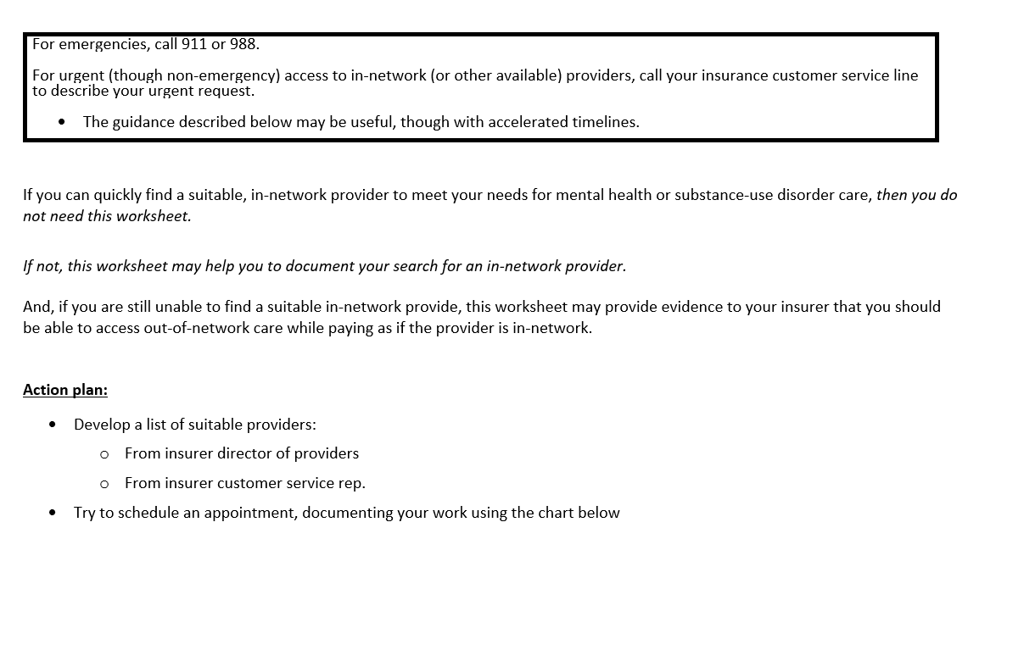

**Worksheet of Contacts with Potential Providers (page 1 of ___)**

| Confirmed in-network? | Provider name, phone | Contact date / person you talked with | Result of contact | | | | |
| --- | --- | --- | --- | --- | --- | --- | --- |
| Insert **✓** if applicable | | |  |  |
| No answer / wrong number | No longer in-network | Not taking new patients | Appointment date offered  (how long a wait?) | Appointment scheduled |
| ✓ |  |  | ✓ | ✓ | ✓ |  |  |
| ✓ |  |  | ✓ | ✓ | ✓ |  |  |
| ✓ |  |  | ✓ | ✓ | ✓ |  |  |
| ✓ |  |  | ✓ | ✓ | ✓ |  |  |
| ✓ |  |  | ✓ | ✓ | ✓ |  |  |

**Worksheet of Contacts with Potential Providers (page 2 of ___)**

| Confirmed in-network? | Provider name, phone | Contact date / person you talked with | Result of contact | | | | |
| --- | --- | --- | --- | --- | --- | --- | --- |
| Insert **✓** if applicable | | |  |  |
| No answer / wrong number | No longer in-network | Not taking new patients | Appointment date offered  (how long a wait?) | Appointment scheduled |
| ✓ |  |  | ✓ | ✓ | ✓ |  |  |
| ✓ |  |  | ✓ | ✓ | ✓ |  |  |
| ✓ |  |  | ✓ | ✓ | ✓ |  |  |
| ✓ |  |  | ✓ | ✓ | ✓ |  |  |
| ✓ |  |  | ✓ | ✓ | ✓ |  |  |