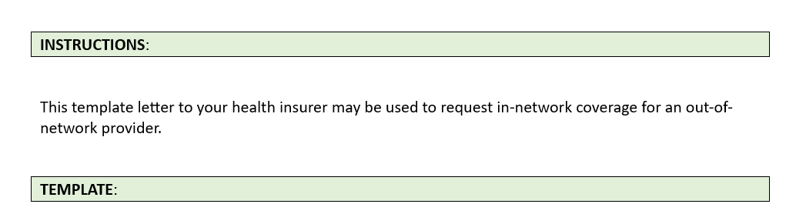

Date

Member: [patient]

Member DOB: […]

To Whom It May Concern:

This is to request coverage of an out-of-network provider at in-network rates because of there being no suitable in-network provider available. This letter is to confirm a call with [NAME OF CUSTOMER SERVICE REP] on [DATE] requesting this coverage.

* Describe the care you require
* Describe your efforts to secure care with a timely appointment with a nearby, appropriate provider. [include a copy of the **completed worksheet documenting your efforts** to find an in-network provider

I have identified [PROVIDER], who meets my current needs, is located near me, and offers an appointment [WITHIN X DAYS].

Access this care is now urgently required. [HEALTH INSURER’s] responsibility for coverage of this care should extend to this out-of-network provider since no in-network provider is available.

Please respond in writing with your confirmation of coverage and the specific terms of that coverage, including:

* Describe the care you require
* The provider of that care
* The currently expected frequency and duration of that care

I look forward to your response within 10 business days of your receipt of this letter.

Thank you.