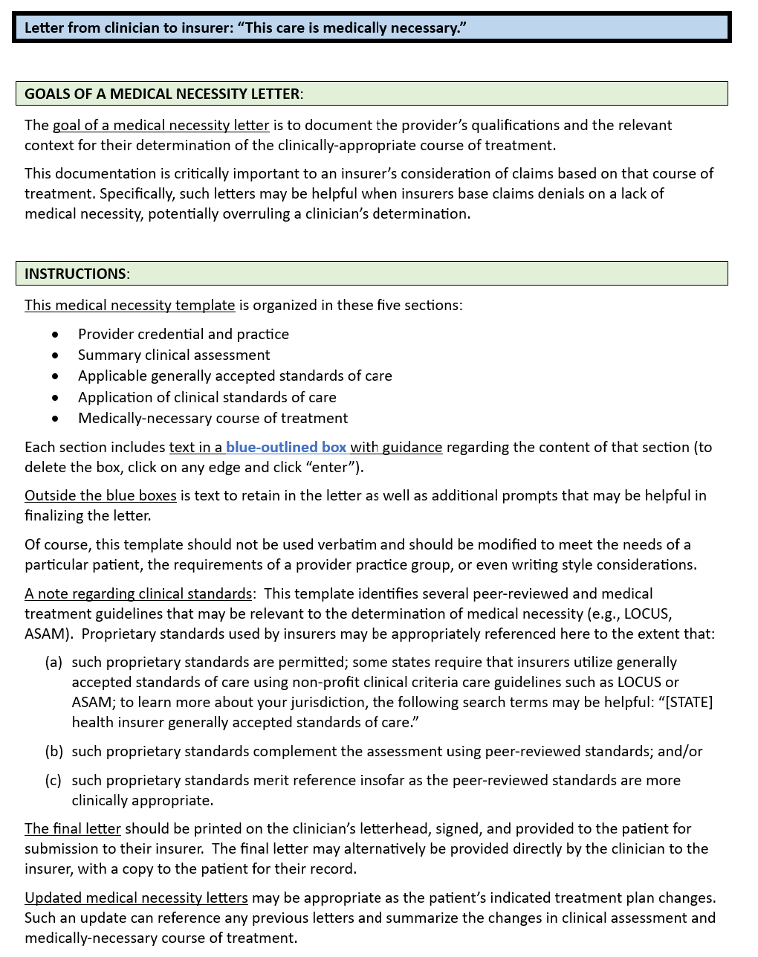

**TEMPLATE**:

Date

Member: [patient]

Member DOB: […]

To Whom It May Concern:

This letter describes my clinical assessment and the medically necessary treatment for *[patient]*. I have been treating *[patient]* since approximately *[date]* and am certifying that this level of care is medically necessary.

[**Provider credentials and practice**] – *include a brief summary of your training, medical or other professional school, residency, fellowship and internship training, hospital affiliations, years in practice, peer-reviewed publications in the area in question, practice focus relevant to the specific patient, and any other description of your qualifications that inform your professional judgment. The information included here will establish your qualifications to make the clinical determination to be described below.*

My clinical specialties and areas of interest include ….

My clinical training has included ….

The above credentials and experience are directly relevant qualifications of my clinical judgment regarding [patient] and the medically-necessary treatment he/she requires.

[**Summary clinical assessment**] – include a brief summary of your diagnosis/assessment, focusing on the particulars relevant to the medically necessary treatment that you have determined is appropriate; include related observations that informed your determination of the treatment plan.

Below is a summary of my diagnosis and assessment of [patient], specifically relevant to the medically-necessary treatment that I have determined is appropriate:

* .
* .
* .

[as appropriate] My assessment included evaluations using these testing instruments or methodologies:

* .
* .
* .

[**response to an insurer denial**] – if the patient has already received a “not medically necessary” denial, this clinical assessment section should include your rationale for that adverse coverage decision being incorrect, any relevant communications with the insurer, level of care commentary, and diagnosis code. If possible, it may be helpful ask the insurer to specify the recommended level of care consistent with their denial.

* …
* …

[**applicable generally accepted standards of care**] – reference applicable generally accepted standards; include any references below appropriate to your clinical assessment and determination of medically-necessary course of treatment; delete those not applicable to this patient and include others relevant this patient.

My assessment and treatment plan are informed by the following peer-reviewed standards and medical treatment guidelines:

* American Association for Community Psychiatrists Level of Care Utilization System (LOCUS);
* American Association for Community Psychiatrists Child and Adolescent Level of Care Utilization System (CALOCUS);
* American Society of Addiction Medicine (ASAM) Criteria;
* Principles of Care for Treatment of Children and Adolescents with Mental Illnesses in Residential Treatment Centers;
* Medicare benefit policy manual (CMS Publication No. 100-02);
* American Psychiatric Association Clinical Practice Guidelines;
* Diagnostic and Statistical Manual of Mental Disorders, 5th ed.
* [other]

My treatment plan derives from these multiple sources such as practice guidelines from professional organizations, guidelines and materials distributed by government agencies, and evidence-based peer-reviewed studies in academic journals. As in all areas of medicine, treatment plans rarely reflect a single source of generally accepted standards of care.

To the extent that this patient’s needs vary from or are atypical vis-à-vis standards and guidelines, it would be helpful to include relevant commentary.

Further, my determinations have been informed by the following symptoms or relevant factors specific to the patient and/or failure of less intensive treatment:

* .
* .

**Application of clinical standards of care** - Include any of the statements below appropriate to your clinical assessment and determination of the medically-necessary course of treatment; delete those that are not applicable to this patient.

Consistent with these generally accepted standards of effective treatment, my treatment plan is based on a multidimensional assessment that accounts for a wide variety of information about *[patient]*;considers treatment of underlying conditions (e.g., early adversity, trauma, chronicity) and is not limited to alleviation of current symptoms;considers treatment of co-occurring behavioral health disorders and/or medical conditions relevant to a determination as to level and type of care; places *[patient]* in the least intensive and restrictive level of care that is both safe and effective; errs on the side of caution in determining level of care; and includes services needed to improve functioning, maintain day-to-day functioning, and to prevent deterioration.

* The appropriate level of care for *[patient]* reflects my professional assessment for its treatment efficacy, patient safety, and overall management of their medical needs.
* My treatment decision regarding the level of care reflects appropriate medical caution after having evaluated *[patient’s]* individual requirements.
* My determination of the treatment duration is based on *[patient’s]* individual needs.
* My treatment plan reflects particular care for the unique needs of [*children/adolescents*] that may be different from those of adults.
* My determination as to the medically appropriate level of care reflects an overall assessment of the patient, based on my [days/weeks/months/years] of observation.
* My determination of the medically appropriate level of care is consistent with that recommended using the [specify criteria for determining level of care].

My consideration of alternative treatment plans has included possibilities that may be considered as “lower levels of care.” In my professional judgment and obligation to “do no harm,” such alternatives are not appropriate for this patient at this time and represent substantial risk to [*patient*].

**[Medically-necessary Course of treatment**] – description of the course of treatment that you have determined to be medically necessary, including as appropriate:

* Summary rationale for medical decision-making
* Peer-reviewed standards and assessment instruments
* Insurance plan definitions of “medical necessity”, if available from patient (patient can obtain this information by reviewing their full Policy (sometimes referred to as the *Subscriber Certificate and Riders* or *Certificate of Coverage*).
* Identify (a) specific harms that could occur, (b) avoidable risks that could be mitigated, and/or (c) clinical gains that could be lost absent your planned course of treatment.

The course of treatment that I have determined to be medically necessary for [patient] includes the following:

* .
* .
* .

Sincerely,

[signature]