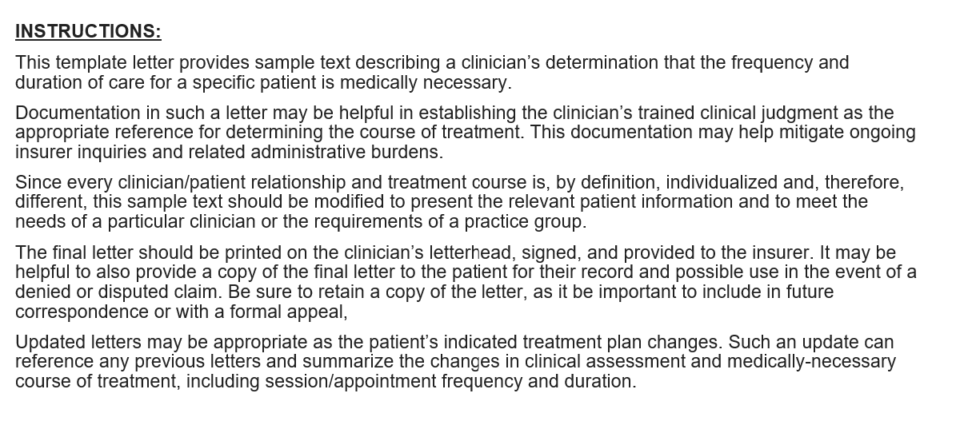

[letterhead]

Date

[Insurance carrier]
[street address]
[city state zip code]
Attention: ____________________

RE: Member: [patient]
Member DOB: [mm/dd/yyyy]

Dear [insurer]:

This letter is in response to the recent contact [specify date and specific person from the insurer] regarding the frequency of appointments for my patient, [patient name]. I am writing to attest to the medical necessity of this clinical care, including the frequency, duration, and applicability of the specific evidence-based treatments, based on my clinical training and expertise, and my direct evaluation and treatment of this patient.

[Patient] has been my patient for approximately [time] and requires treatment for [insert brief description only]. My training [insert description of training and specific accreditations] is appropriate to diagnose and prepare a treatment plan for [patient] in particular.

The goals of the specific course of treatment for [patient] are to maintain day-to-day functioning, to prevent/mitigate deterioration/regression, and to support recovery. These goals are the Generally Accepted Standards of Care, and my patient care is aligned with and guided by these Standards. In particular it is my medical judgment, based on my training and experience wit this patient, that the number of days of therapy I have provided this patient is medically necessary and appropriate. As with physical health, treatment plans are individualized based on multiple factors including the patient’s presenting problems, their severity, initial onset and duration, the presence of co-occurring disorders, the patient’s coping style, available resources, the number and type of ongoing stressors. It is not uncommon that multiple appointments per week and/or shifting appointment durations may be necessary based on an individual patient’s requirements, presentation, and response to treatment. This is one such case, based on my clinical training, experience, and peer-reviewed standards, after having spent substantial time with the patient in preparation for and during therapy sessions.

Thank you.

Sincerely,

[signature]

