Quick Guide to Cover My Mental Health Website

Instructions:
This no-cost content is available to use to help advocate for coverage and care through your communications channels.
Simply copy/download/open the content and add it to your newsletter, blog, website, and/or social media posts to help people better advocate for coverage and care.

CoverMyMentalHealth.org is a new nonprofit organization, dedicated to providing no-cost resources to individuals and families facing insurance barriers to their mental health care.

Download this easy-to-use PDF for use as a “quick guide” to the website with links to the forms and tools available.

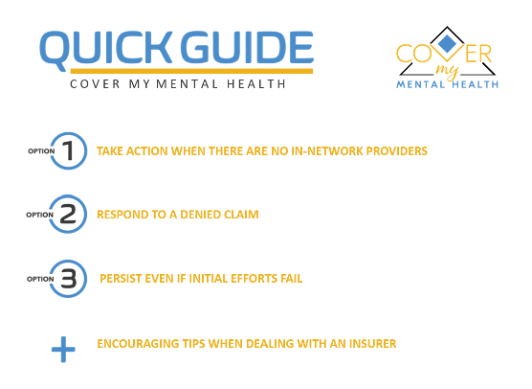

The Cover My Mental Health website offers guidance and practical tools for patients and their families when insurance companies deny mental health care claims or when no in-network provider is available. You don’t have to take no for an answer, and you’re not in this alone.

Thanks for your ongoing support. And as always, your feedback is greatly welcome.
We welcome you including contenthub@covermymentalhealth.com on your distribution list or sharing your use of these resources with us.

