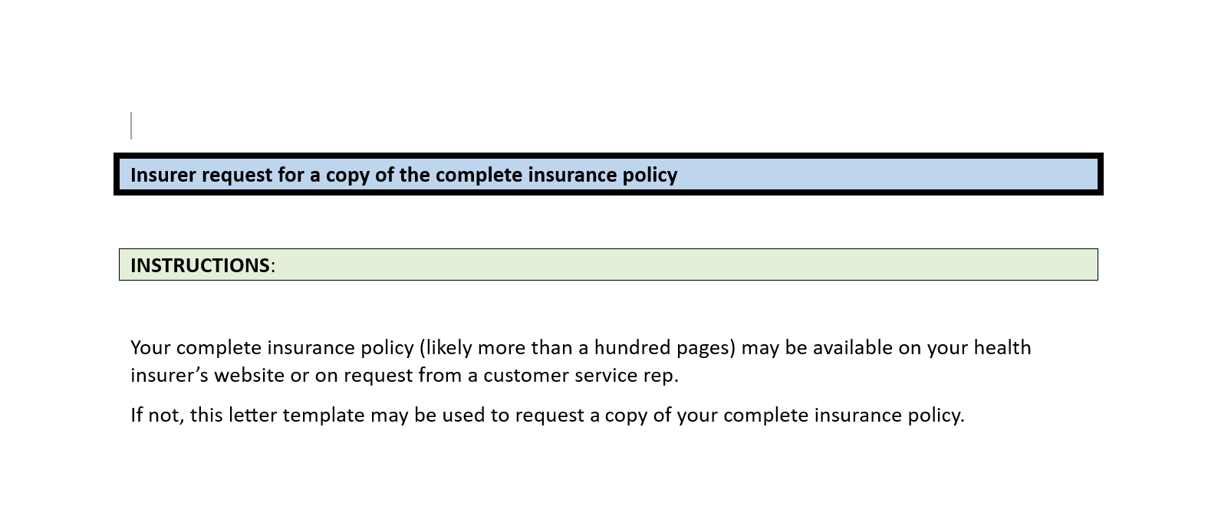

Date

[HEALTH INSURER]

To whom it may concern:

This is to request that a copy of the complete insurance policy[1] be sent to me soonest possible to [INSERT YOUR PREFERRED EMAIL ADDRESS OR PHYSICAL ADDRESS].

My group # is ____ and policy # is _____.

I have been unsuccessful finding a copy online. My request to [CUSTOMER SERVICE REP] on [DATE] had not resulted in my receiving a copy of the complete policy.

Thank you.

1. Summary Plan Description (SPD), Certificate of Coverage (COC), Evidence of Coverage (EOC), or maybe something else.