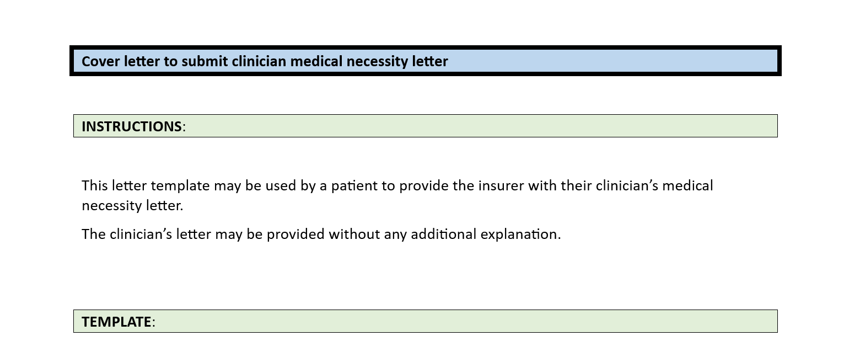

Date

Member: [patient]

Member DOB: […]

To Whom It May Concern:

Please find attached a letter from [clinician] dated [xxxx] regarding the medically-necessary treatment required for [patient].

Thank you.