* + 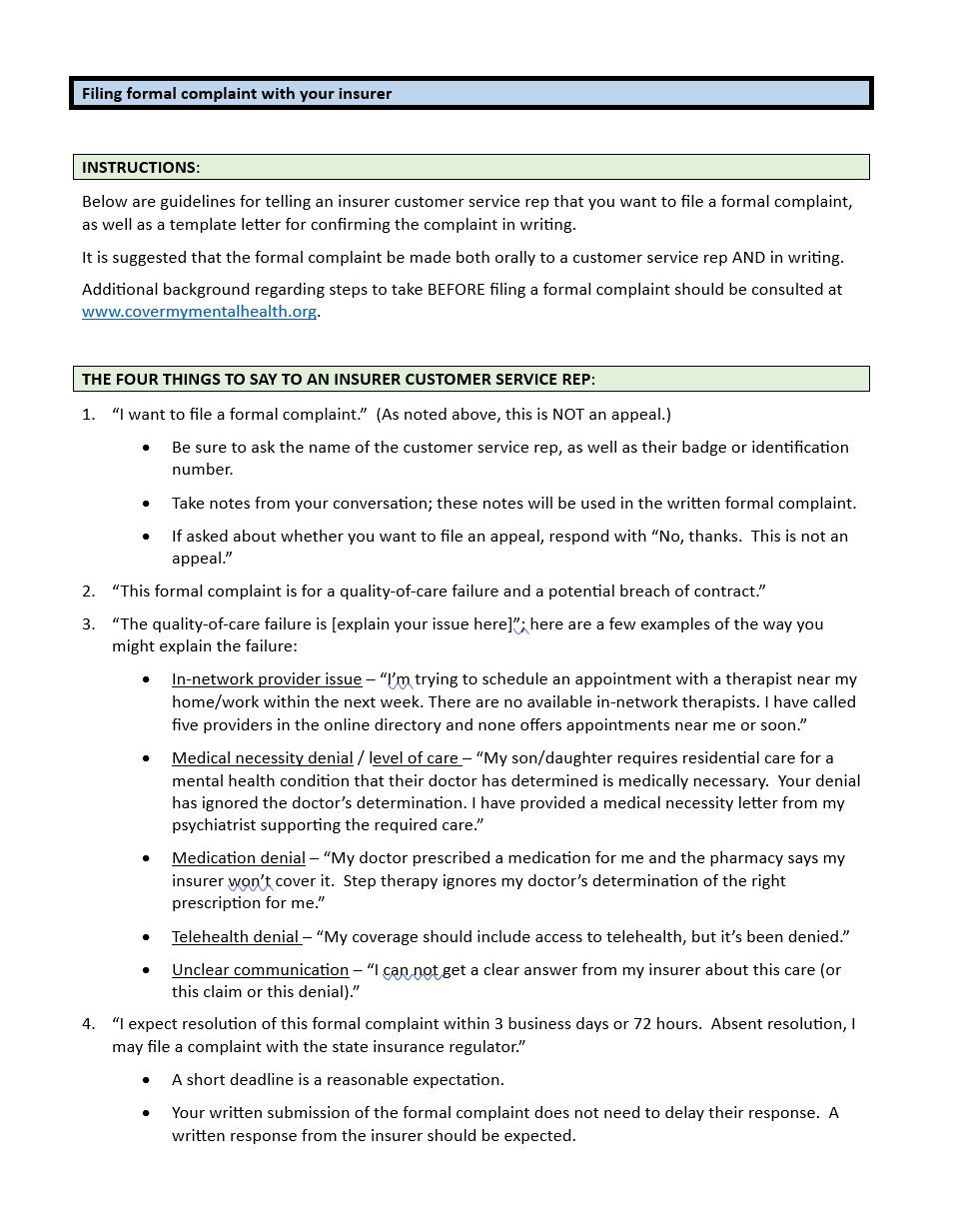

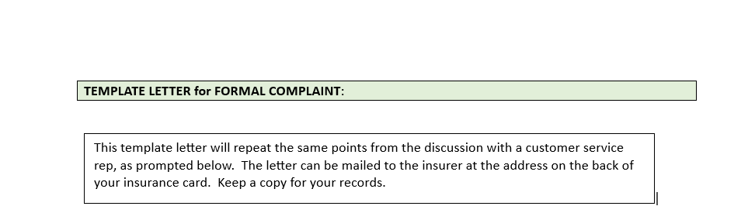

Date

Member: [patient]

Member DOB: […]

To Whom It May Concern:

This is a formal complaint for a quality-of-care failure. This complaint was submitted in a discussion with [customer service rep] on [date].

I experienced a “quality-of-care” failure as follows:

* Describe the care you require and the result you expect from the formal complaint
* Describe the obstacles you have encountered
* Describe what you have done to overcome the obstacles
* Report the deadline

Thank you.