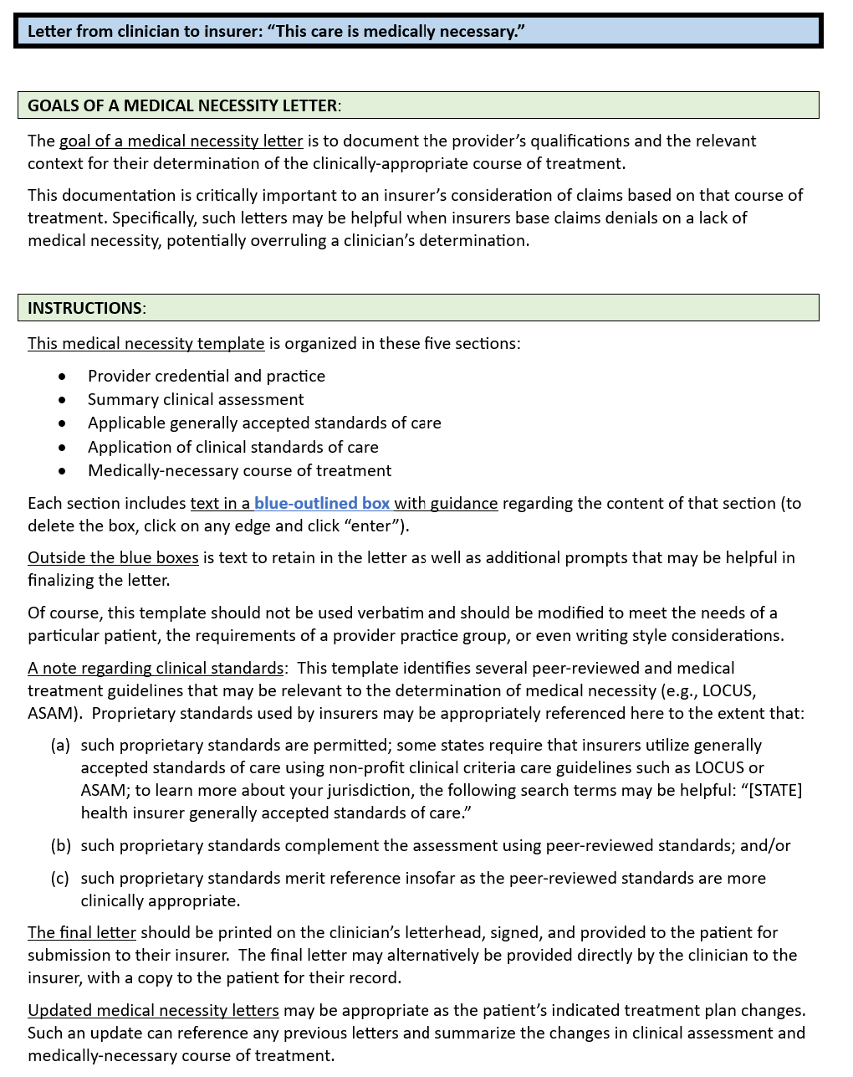

**TEMPLATE**:

Date

Member: [patient]

Member DOB: […]

To Whom It May Concern:

This letter describes my clinical assessment and the medically necessary treatment for *[patient]*. I have been treating *[patient]* since approximately *[date]* and am certifying that this level of care is medically necessary.



My clinical specialties and areas of interest include ….

My clinical training has included ….

The above credentials and experience are directly relevant qualifications of my clinical judgment regarding [patient] and the medically-necessary treatment he/she requires.



Below is a summary of my diagnosis and assessment of [patient], specifically relevant to the medically-necessary treatment that I have determined is appropriate:

* .
* .
* .

[as appropriate] My assessment included evaluations using these testing instruments or methodologies:

* .
* .
* .



* …
* …



My assessment and treatment plan are informed by the following peer-reviewed standards and medical treatment guidelines:

* American Association for Community Psychiatrists Level of Care Utilization System (LOCUS);
* American Association for Community Psychiatrists Child and Adolescent Level of Care Utilization System (CALOCUS);
* American Society of Addiction Medicine (ASAM) Criteria;
* Principles of Care for Treatment of Children and Adolescents with Mental Illnesses in Residential Treatment Centers;
* Medicare benefit policy manual (CMS Publication No. 100-02);
* American Psychiatric Association Clinical Practice Guidelines;
* Diagnostic and Statistical Manual of Mental Disorders, 5th ed.
* [other]

My treatment plan derives from these multiple sources such as practice guidelines from professional organizations, guidelines and materials distributed by government agencies, and evidence-based peer-reviewed studies in academic journals. As in all areas of medicine, treatment plans may reflect one or more generally accepted standards of care.



Further, my determinations have been informed by the following symptoms or relevant factors specific to the patient and/or failure of less intensive treatment:

* .
* .



Consistent with these generally accepted standards of effective treatment, my treatment plan is based on a multidimensional assessment that accounts for a wide variety of information about *[patient]*;considers treatment of underlying conditions (e.g., early adversity, trauma, chronicity) and is not limited to alleviation of current symptoms;considers treatment of co-occurring behavioral health disorders and/or medical conditions relevant to a determination as to level and type of care; places *[patient]* in the least intensive and restrictive level of care that is both safe and effective; errs on the side of caution in determining level of care; and includes services needed to improve functioning, to maintain day-to-day functioning, to prevent deterioration, and in pursuit of recovery.

* The appropriate level of care for *[patient]* reflects my professional assessment for its treatment efficacy, patient safety, and overall management of their medical needs.
* My treatment decision regarding the level of care reflects appropriate medical caution after having evaluated *[patient’s]* individual requirements.
* My determination of the treatment duration is based on *[patient’s]* individual needs.
* My treatment plan reflects particular care for the unique needs of [*children/adolescents*] that may be different from those of adults.
* My determination as to the medically appropriate level of care reflects an overall assessment of the patient, based on my [days/weeks/months/years] of observation.
* My determination of the medically appropriate level of care is consistent with that recommended using the [specify criteria for determining level of care].

My consideration of alternative treatment plans has included possibilities that may be considered as “lower levels of care.” In my professional judgment and obligation to “do no harm,” such alternatives are not appropriate for this patient at this time and represent substantial risk to [*patient*].



The course of treatment that I have determined to be medically necessary for [patient] includes the following:

* .
* .
* .

Sincerely,

[signature]