Cover My Mental Health – Infographic for Overcoming Insurance Denials

Instructions:
This no-cost content is available to use to help advocate for coverage and care through your communications channels.
Simply copy/download/open the content and add it to your newsletter, blog, website, and/or social media posts to help people better advocate for coverage and care. If posting on social media, please add #covermymentalhealth. Thanks.

Cover My Mental Health is your go-to resource for overcoming insurance obstacles.

www.CoverMyMentalHealth.org provides no-cost resources and practical tools to help patients and their families overcome insurance barriers to their mental health care.

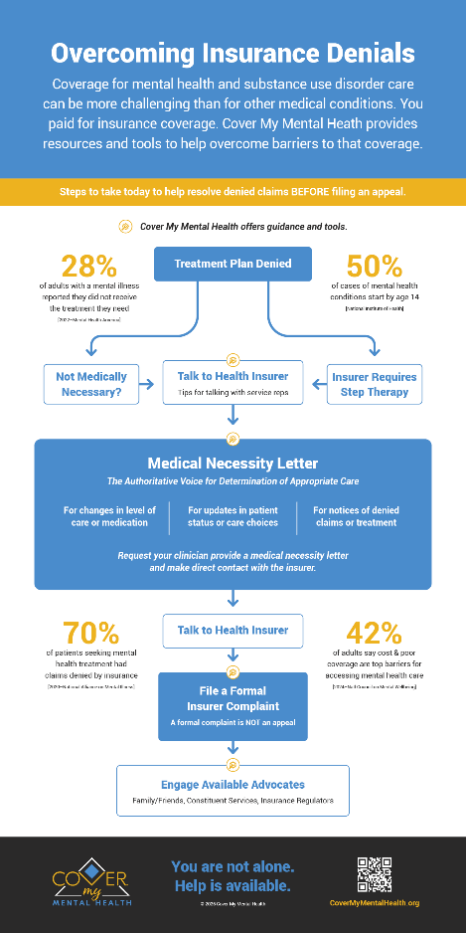

This Cover My Mental Health infographic highlights steps to take to help resolve denied claims BEFORE filing an appeal, all supported by the encouragement and no-cost resources at CoverMyMentalHealth.org.


Thanks for your ongoing support. And as always, your feedback is greatly welcome.
We welcome you including contenthub@covermymentalhealth.com on your distribution list or sharing your use of these resources with us.

