A Mental Health Insurance Coverage Success Story

Instructions:
This no-cost content is available to use to help advocate for coverage and care through your communications channels.
Simply copy/download/open the content and add it to your newsletter, blog, website, and/or social media posts to help people better advocate for coverage and care.

A Mental Health Insurance Coverage Success Story

The resources and tips provided at CoverMyMentalHealth.org offer help and hope in the struggle to compel insurance companies to pay for mental health care. Here’s a success story from Michael Groat, PhD, Associate Professor of Psychiatry and Behavioral Neuroscience and President/CEO, of the Lindner Center of Hope, showing that these tools and templates can work.
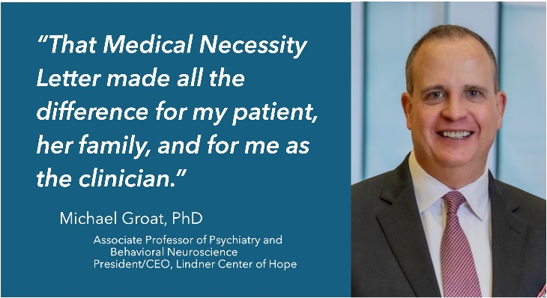

"In my work with a young adult who presented complex [medical conditions], I soon recognized the insurance support available for residential care or intensive outpatient treatment would be insufficient. She and her family were facing yet again another round of protracted battles to eke out meager payments, if any at all. My patient and her family had plenty on their plate and dealing with their insurer was surely more than they needed at that time.

"After receiving the anticipated and unwarranted denial deeming her care ‘not medically necessary” treatment, I knew that the insurer could not have the last word. My patient, and others like her, deserved better.

"I documented my clinical assessment using the Cover My Mental Health medical necessity letter template shared in a Journal of Psychiatric Practice article authored by Joe Feldman (president of Cover My Mental Health), Dr. Eric Plakun (Medical Director and CEO at Austen Riggs Center) and Mark DeBofsky (litigator and expert in health insurance at DeBofsky Law).

"That medical necessity letter made all the difference for my patient, her family, and for me as the clinician responsible for her care. The insurer reversed their unsubstantiated denial, approving the required care, and relieved the family of an unnecessary burden."

- Michael Groat, PhD, Associate Professor of Psychiatry and Behavioral Neuroscience and President/CEO, of the Lindner Center of Hope

Thanks for your ongoing support. And as always, your feedback is greatly welcome.
We welcome you including contenthub@covermymentalhealth.com on your distribution list or sharing your use of these resources with us.

