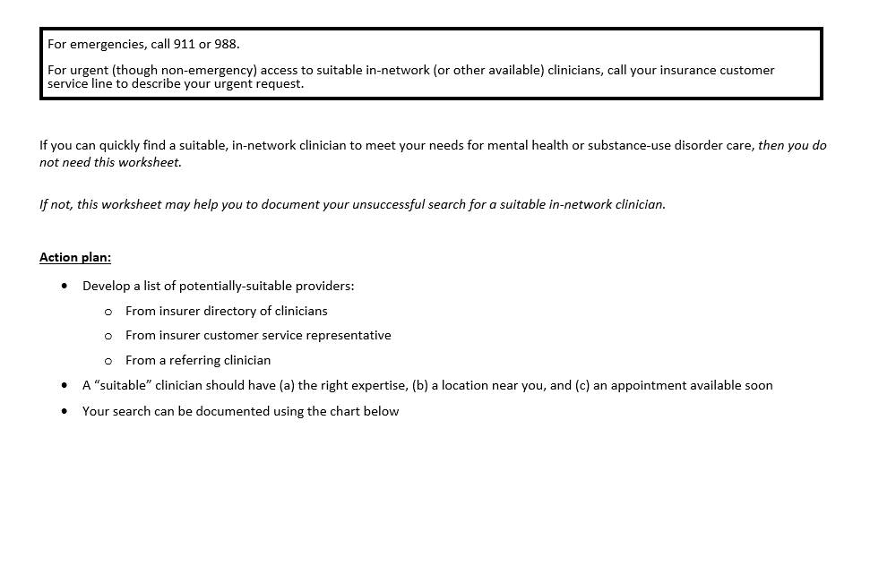

Worksheet of Contacts with Potential Clinicians (page 1 of ___)

Confirmed in-network? | Clinician name, phone | Contact date / person you talked with | Result of contact indicating that this clinician is not suitable
Confirmed in-network? | Clinician name, phone | Contact date / person you talked with | Insert if applicable
Confirmed in-network? | Clinician name, phone | Contact date / person you talked with | No answer / wrong number | No longer in-network | Not taking new patients | Appointment date offered  (how long a wait?) | Clinical expertise not suitable:  - Specialized training lacking  - Specialized certification lacking  - Other expertise concerns

Worksheet of Contacts with Potential Clinicians (page 1 of ___)

Confirmed in-network? | Clinician name, phone | Contact date / person you talked with | Result of contact indicating that this clinician is not suitable
Confirmed in-network? | Clinician name, phone | Contact date / person you talked with | Insert if applicable
Confirmed in-network? | Clinician name, phone | Contact date / person you talked with | No answer / wrong number | No longer in-network | Not taking new patients | Appointment date offered  (how long a wait?) | Clinical expertise not suitable:  - Specialized training lacking  - Specialized certification lacking  - Other expertise concerns

